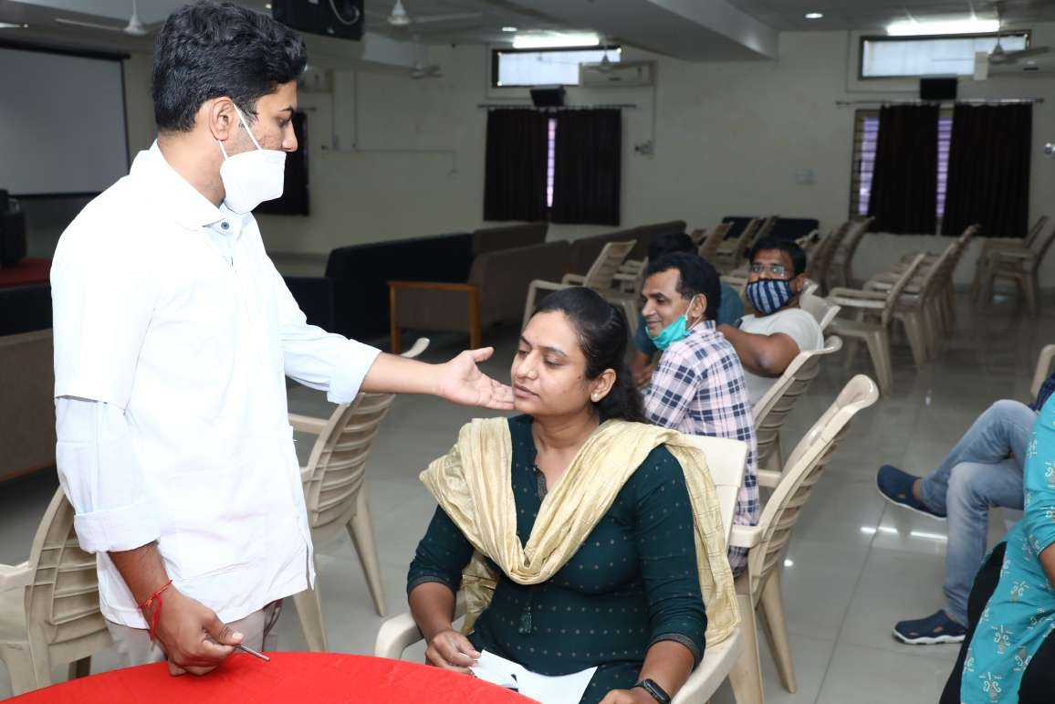

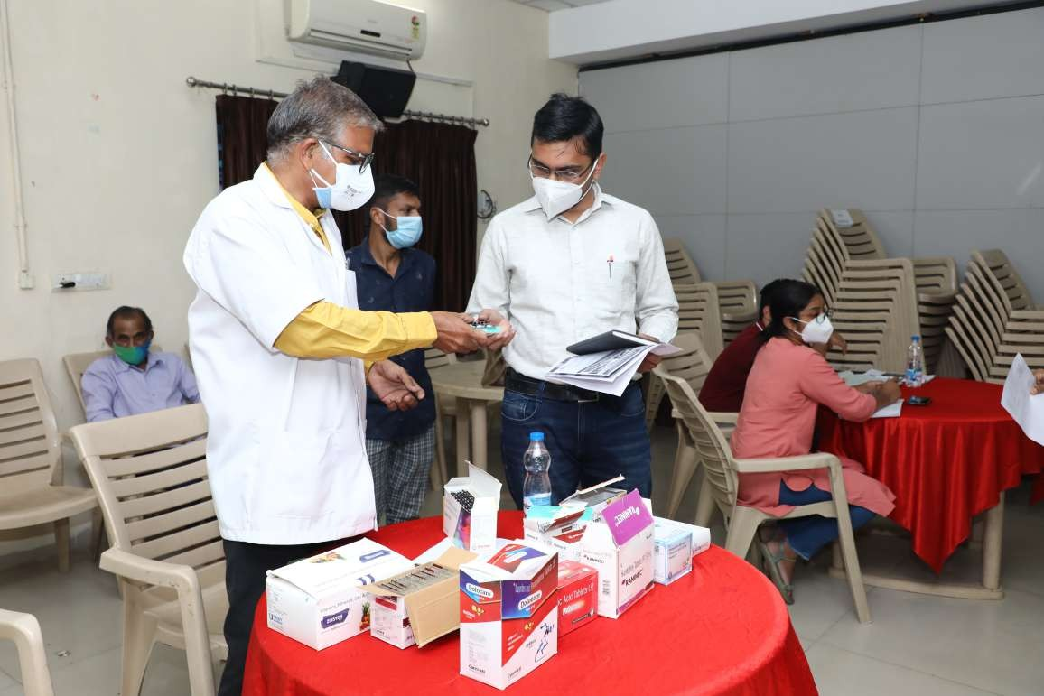

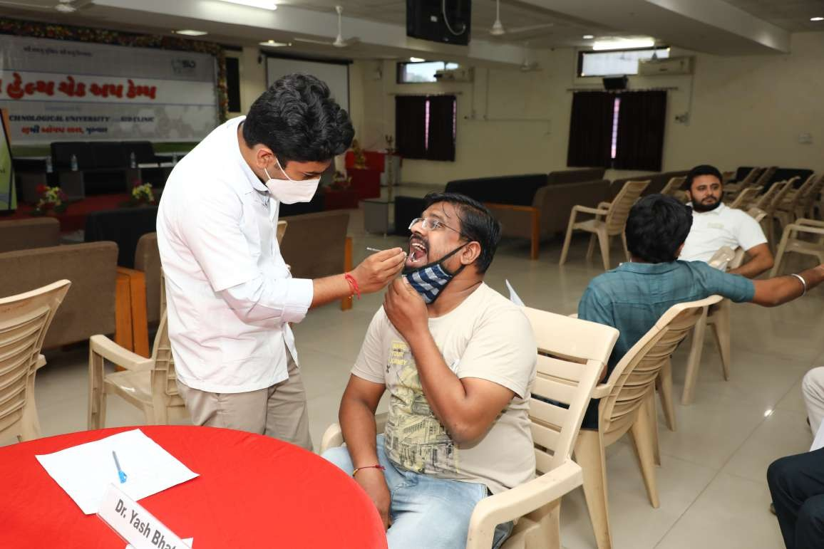

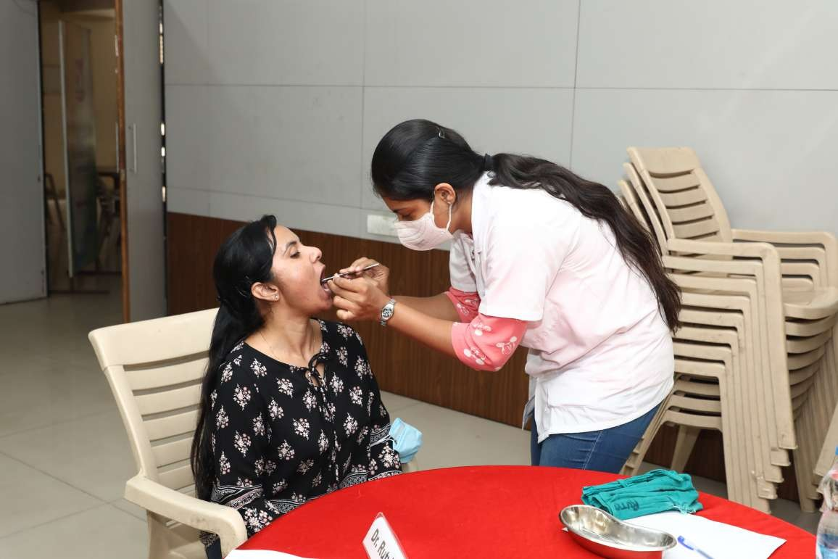

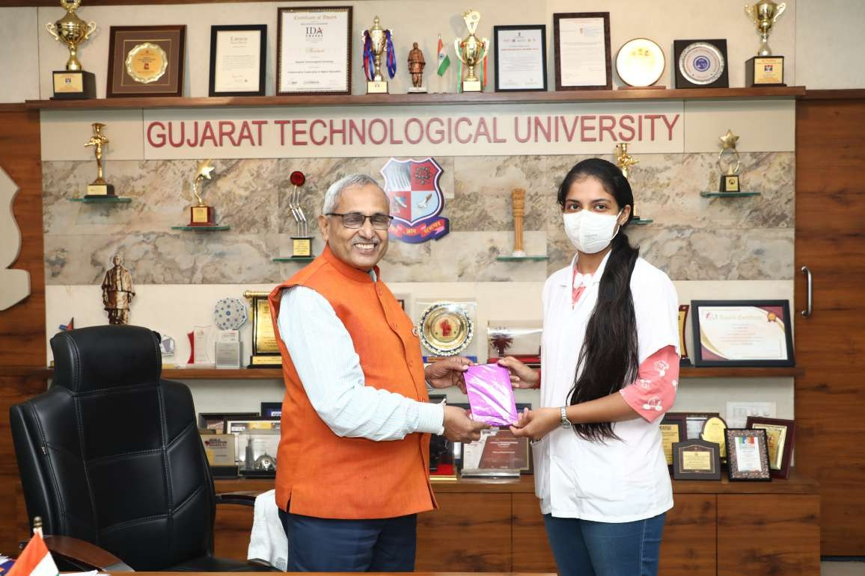

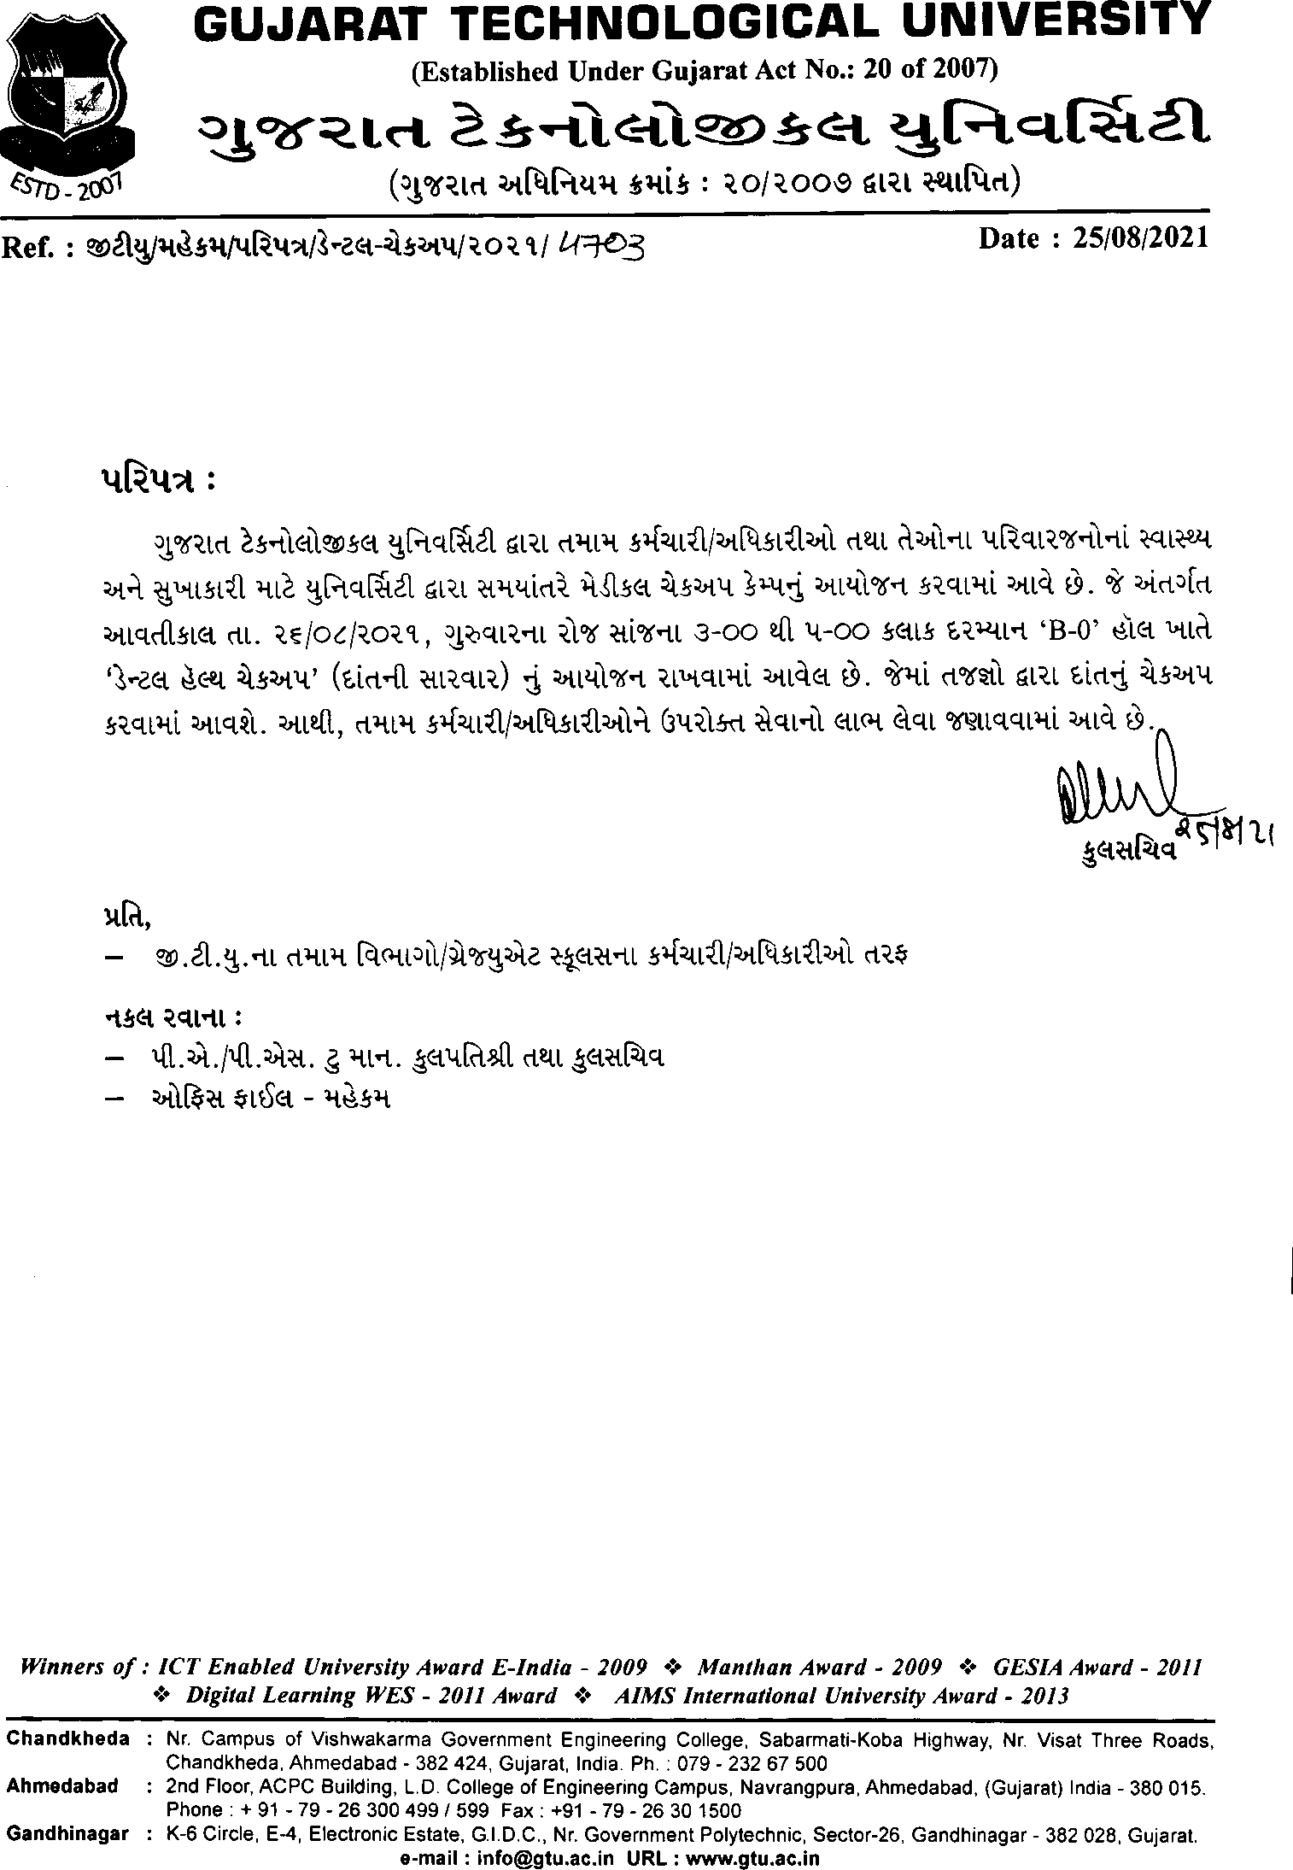

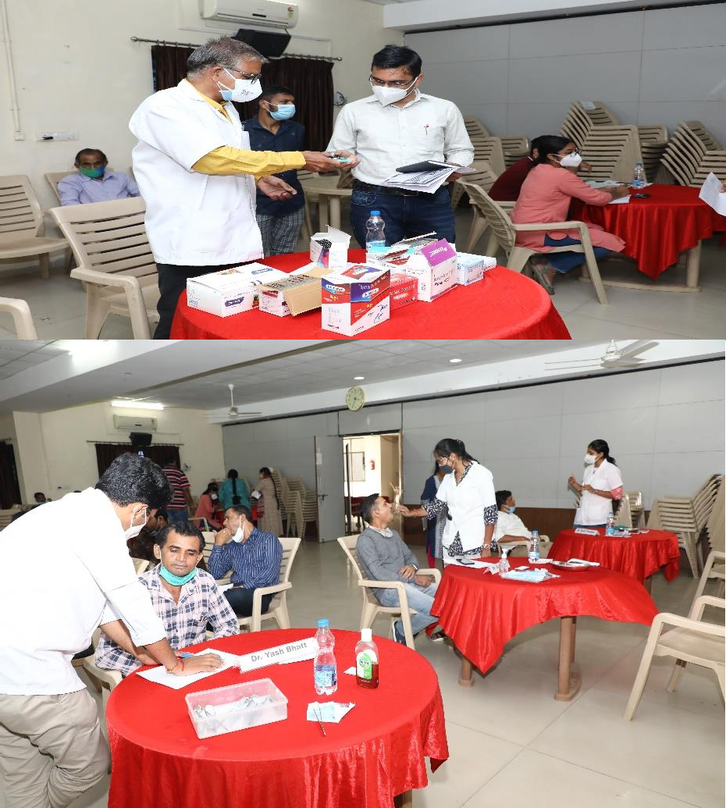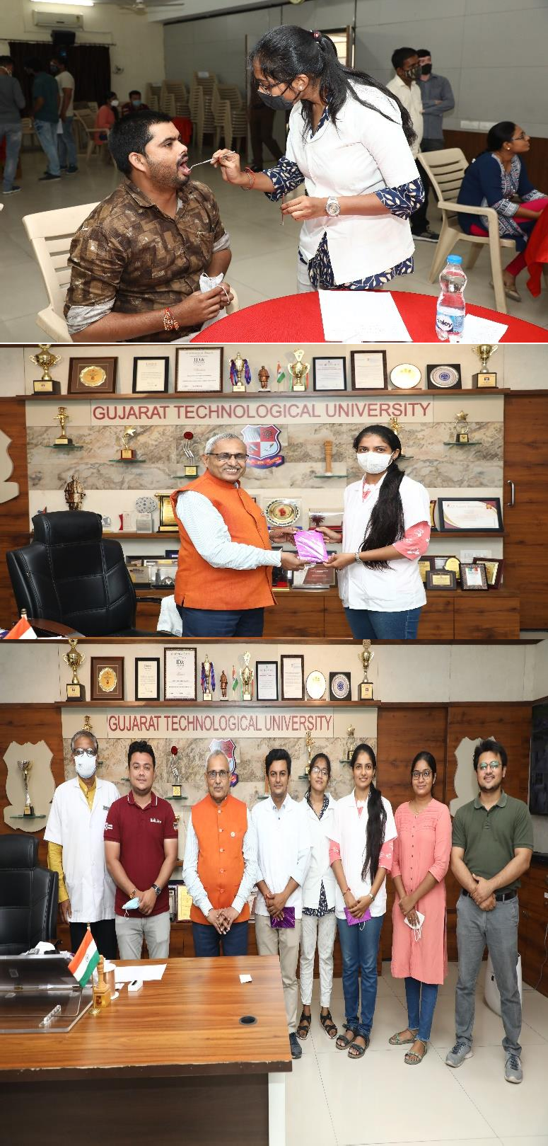

Dental Check-Up camp GTU Chandkheda Campus conducted on 26/08/2021

Gujarat Technological University Has Organized “Dental Checkup Camp ” On Dated 26/08/2021. More Than 65 Staff Members, Family Members, Faculties Were Come For Dental Checkup Camp Total No. of 73 GTU PG School’s students also participated in this event.

And Doctors Advise Patients And Gave Them Medicines According To Their Problems.

Invitees Dignitaries
Prof. (Dr.) Navin Sheth Dr. K. N. Kher
Vice Chancellor, GTU Registrar, GTU

Dr. Yash Bhatt Dr. Sanjay Joshi
SID Clinic Medical Officer,
GTU
Dr. Akash Gohil Sports Officer, GTU

